Multiplier Event (SPAIN)
20th September 2019

Event Title: Entrepreneurship for all in the digital age

Location: CEOE / Diego de León, 50. Sala Carlos Ferrer Salat (antiguo Hemiciclo). Organized by Universidad Politécnica de Madrid (UPM) and Confederación Española de Centros de Enseñanza (CECE).

http://www.emadridnet.org/index.php/en/events/1124-emadrid-seminar-on-entrepreneurship-for-all-in-the-digital-age

Agenda:
Timings | Session
11.00 - 11.45 | «EntreCom4ALL: an online platform for the social development of entrepreneurial skills through OER».  - Edmundo Tovar, associate professor at UPM.  - Bernardo Tabuenca, assistant professor at UPM.  - Tomás Serrano, educational project manager at CECE (Confederación Española de Centros de Enseñanza)
11.45 - 12.15 | «EntreCompEdu: developing teachers' entrepreneurial skills».  - Paloma Lozano, Director. Innogate to Europe.
12.15 - 12.45 | «Evolution and new approaches to elearning for entrepreneurs in the current digital age»  - Belén Sandoval Rodríguez, Head of the Academy area of OPINNO, an innovation consultant dedicated to the training and development of people and organizations for digital transformation.
12.45 - 13.30 | Mini Business Programme «Learning to Entrepreneur» for students aged 15 to 19.  - Javier Samarán, head of Operations for Junior Achievement's Entrepreneurs Area.
13.30 | Spanish wine sponsored by EntreCom4ALL.

Facilitator’s Comments:
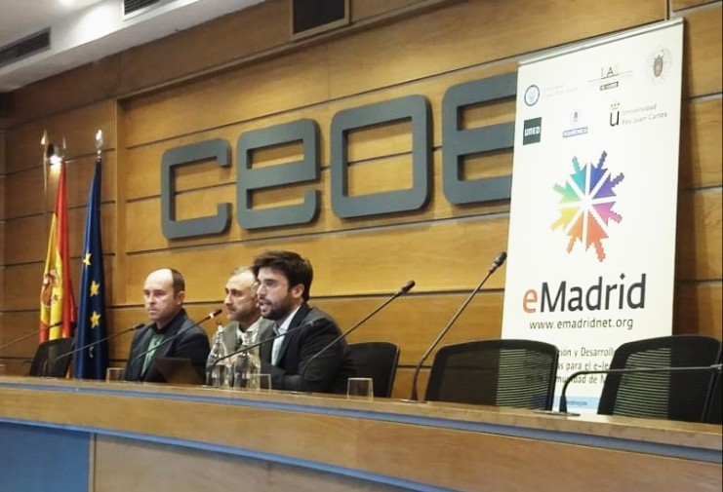
UPM and CECE organized an event of entrepreneurship in the digital age. There, we counted with the participation of different speakers, each specialized in a specific area.
The event started with the presentation of the platform and main deliverable created by the project EntreCom4All.
First, Edmundo Tovar, from UPM, the coordinating organization of EntreCom4ALL project, talked about the objectives of EntreCom4ALL and the adaptation of the European Commission model EntreComp for the different target groups we acknowledged in the project.
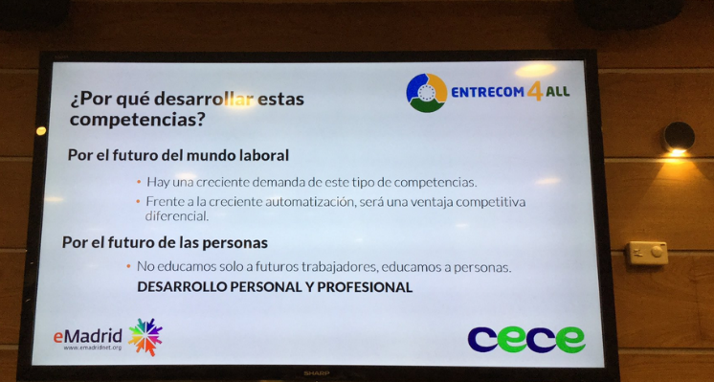
Then, Bernardo Tabuenca, from UPM as well, explained the different functionalities that the platform offers and how to use them.
To end the EntreCom4ALL presentation, Tomás Serrano, from CECE presented a practical case on how to use the platform if you are an educational centre.
The event continued with Paloma Lozano, director from Innogate to Europe, which talked about the development of entrepreneurial competences of teachers, also centred in this development within the EntreComp framework.
Belén Sandoval Rodríguez, director of the Academy area of ​​OPINNO, innovation consultant dedicated to the training and development of people and organizations in digital transformation, OPINNO, came to give a talk about the evolution and new approaches to elearning for entrepreneurs in the current digital era. During the presentation, she showed the audience different practical and success cases and answered to doubts from the audience.
To end the event, Javier Samarán, Director of Operations of the Entrepreneurs Area of ​​Junior Achievement, explained the Junior Achievement project and what they are aiming to achieve in the different educational levels, before centering in the “Miniempresas” project, a project to foment entrepreneurship activities in middle and high-school.

UPM and CECE organized an event of entrepreneurship in the digital age. There, we counted with the participation of different speakers, each specialized in a specific area.
The event started with the presentation of the platform and main deliverable created by the project EntreCom4All.
First, Edmundo Tovar, from UPM, the coordinating organization of EntreCom4ALL project, talked about the objectives of EntreCom4ALL and the adaptation of the European Commission model EntreComp for the different target groups we acknowledged in the project.
Then, Bernardo Tabuenca, from UPM as well, explained the different functionalities that the platform offers and how to use them.
To end the EntreCom4ALL presentation, Tomás Serrano, from CECE presented a practical case on how to use the platform if you are an educational centre.
The event continued with Paloma Lozano, director from Innogate to Europe, which talked about the development of entrepreneurial competences of teachers, also centred in this development within the EntreComp framework.
Belén Sandoval Rodríguez, director of the Academy area of ​​OPINNO, innovation consultant dedicated to the training and development of people and organizations in digital transformation, OPINNO, came to give a talk about the evolution and new approaches to elearning for entrepreneurs in the current digital era. During the presentation, she showed the audience different practical and success cases and answered to doubts from the audience.
To end the event, Javier Samarán, Director of Operations of the Entrepreneurs Area of ​​Junior Achievement, explained the Junior Achievement project and what they are aiming to achieve in the different educational levels, before centering in the “Miniempresas” project, a project to foment entrepreneurship activities in middle and high-school.

