Multiplier Event (ITALY)
18th October 2019
Event Title: Entrepreneurial mindset & skills in the European context - EntreCom4ALL EU project presentation
Location: Technical Institute (Technological Sector) G.Pentasuglia, Via E. Mattei snc -75100 Matera (Italy)
Agenda:
Timings | Session
9:00 | Registration participants
9:30 | Presentation of the day's program
9:45 | The opportunities of the European Commission for young people who want to start a business or work abroad – The context for EntreCom4ALL
10:30 | Entrepreneurial mindset & skills in the European context - EntreCom4ALL EU project presentation
11.30 | EntreCom4ALL platform – hands on session
12:30 | The funds and programs of the Basilicata Region to support young entrepreneurs (Guest: Giuseppe Sabia – Basilicata Region – FESR office)
13:30 | Conclusion

Facilitator’s Comments:
The event organized in Matera by Materahub with the support of Jobbin Fest was run with a focus on the EntreComp4All project, its products but also with a wider perspective to integrate the project in the vision of the EU on entrepreneurship education and on the local resources for startups with the support of the Basilicata Region to promote projects and initiatives that support young people in the region to gain work experience and to learn about the opportunities of the European Commission. The Matera event was organized in collaboration with Materahub, to present the Entrecom4ALL project and to promote the opportunities of the European Commission for young entrepreneurs. Materahub is also the “Europe Direct Center” of the area of Matera, so it is a point of reference for local organizations & people.
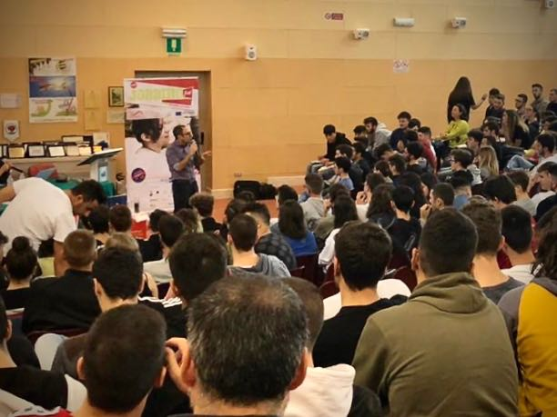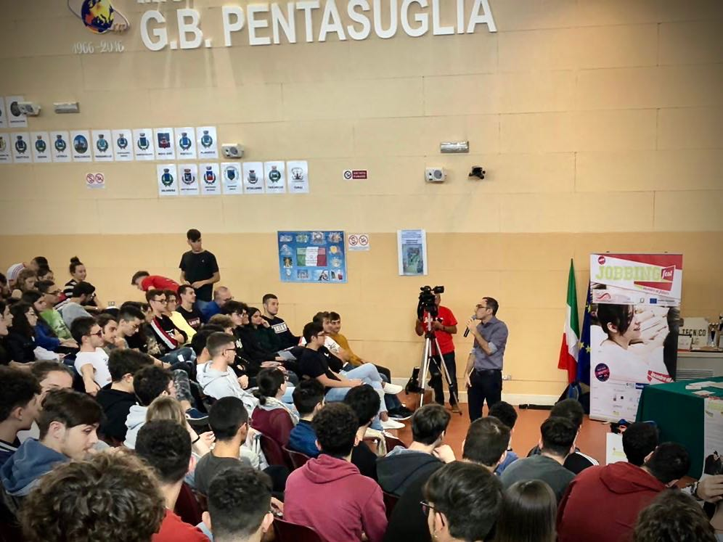
The majority of the participants were university students with the profile of potential young entrepreneurs; there were also some educators, teachers, coaches and mentors. The event was organized in the high school "Industrial and technological institute G.Pentasuglia" of Matera, very famous because it runs various experimental programs for entrepreneurial education to young people.
The young entrepreneurs were involved through practical examples and thanks to an interactive presentation of the contents, which involved them making direct questions and favoring their participation.
Some young entrepreneurs were also invited to share their experience during the presentation of each of the 3 moments of presentation.
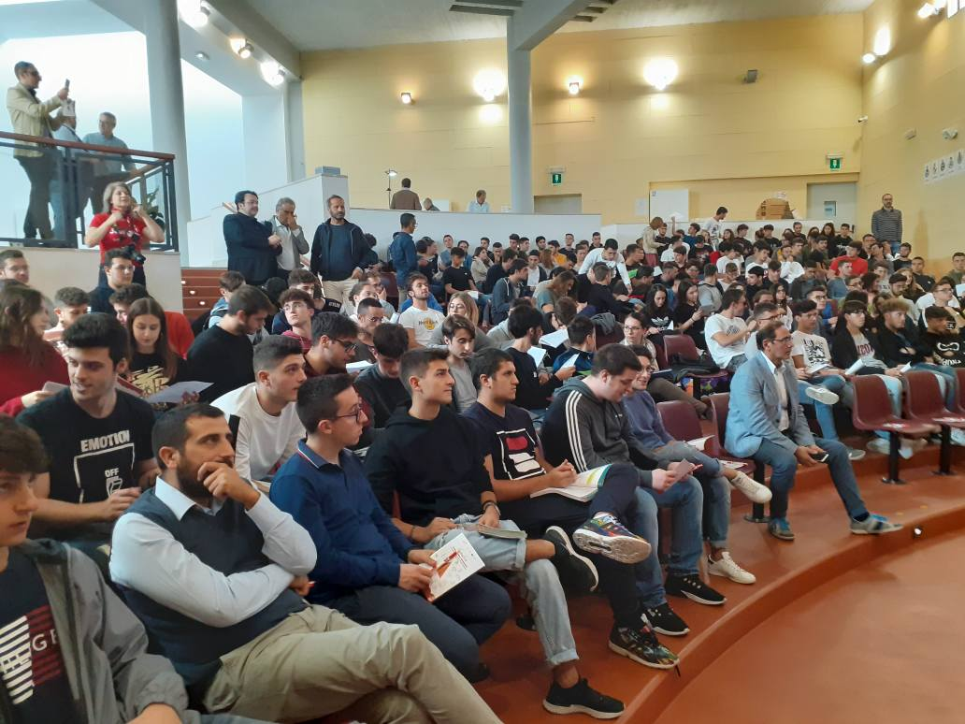
Basilicata is working a lot with the new generations, because in recent years our territory is becoming depopulated and young people are migrating out of the region. For this reason it is necessary to encourage young people to build new entrepreneurial paths that can help them stay in their territory, in different sectors, such as tourism, cultural and creative industries, agriculture, manufacturing.
The young people are very enthusiastic and always respond positively to this type of meetings. During the event there were many practical questions and many wanted to know more about Entrecomp's themes and entrepreneurial skills. The event served to imagine new design scenarios with the startup world and with the Basilicata Region, which made itself available to build a regional work table to discuss how to introduce entrepreneurial education in Basilicata schools.
The event was promoted at regional level through social media and some very important journalistic heads.
